Analysis of National Learning Assessment Systems [ANLAS]
<Country name>: Key Findings

Introduction
The Analysis of National Learning Assessment Systems (ANLAS) has been initiated by the Global Partnership for Education (GPE) as part of the Assessment for Learning (A4L) initiative to provide a resource for countries around the world to systematically gather and analyze information about their national learning assessment system. The comprehensive analysis is qualitative in nature. It is implemented as a country-led, participative process that involves key stakeholders in the education system and the assessment system. The analysis process enables key stakeholders to collaboratively analyze the current learning assessment system and identify where improvements can be made. Those findings can then be used to develop a set of recommendations on how the system can be strengthened. Based on these recommendations, strategies can then be developed and implemented through the country’s education sector planning process.
The ANLAS model illustrated in Exhibit 1 provides the framework for ANLAS.
Exhibit 1: The ANLAS model
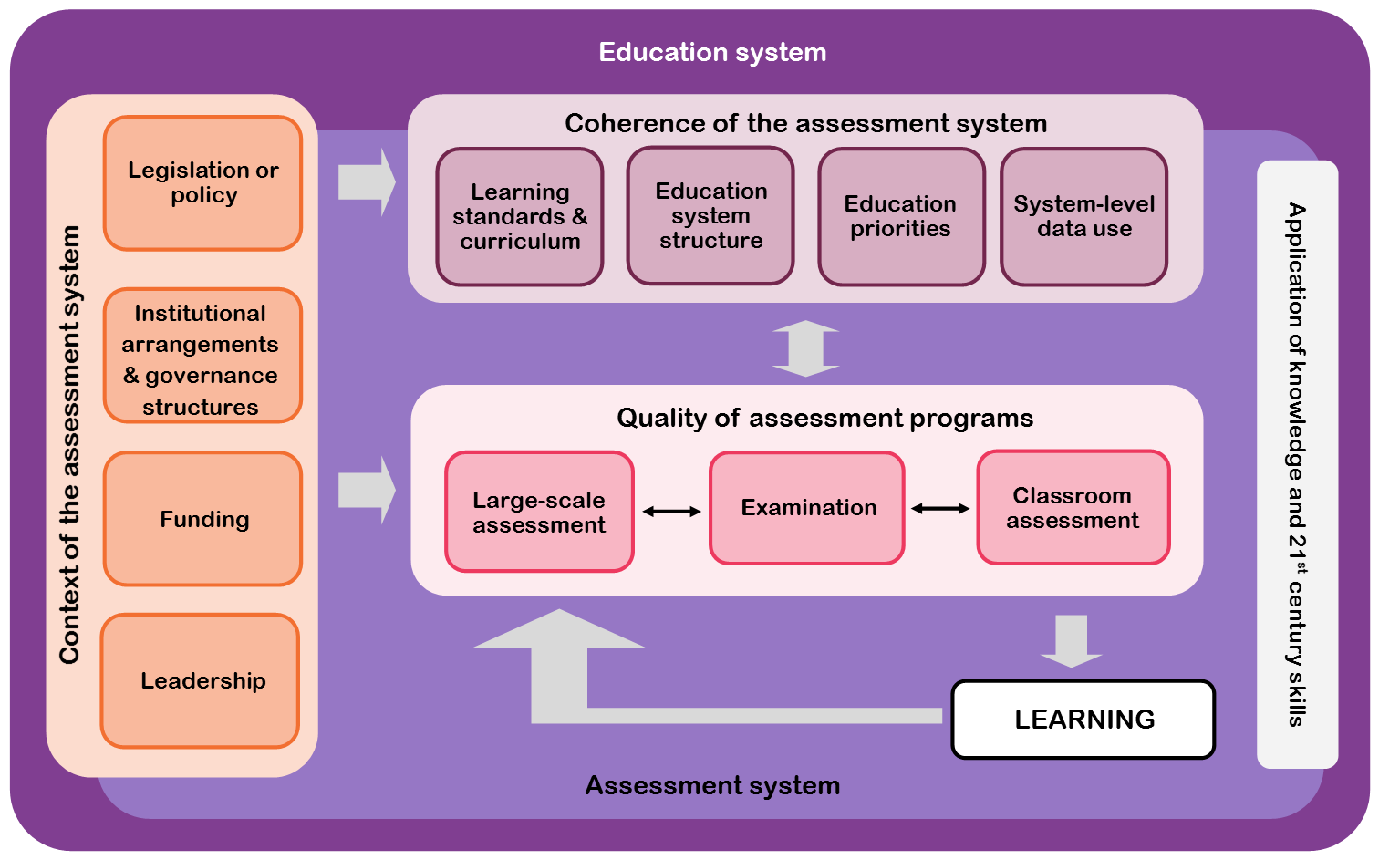
The ANLAS model focuses on three dimensions:
- Context of the assessment system, at central as well as decentralized levels
- Quality of assessment programs: large-scale assessment, examination and classroom assessment
- Coherence of the assessment system, with regard to the wider education system and other elements within the assessment system.
An important element of ANLAS that is relevant to all three dimensions is the application of knowledge and 21st century skills – that is, skills that are considered important to succeed in today’s knowledge-based society in which innovation and technology are predominant. Other terminology commonly used to describe this set of skills includes general capabilities, transversal competencies or cross-curricular competencies. Prominent examples of such skills are problem solving, critical thinking, creativity, communication, collaboration, and social-emotional skills (for example, intrapersonal, interpersonal, empathy). Assessing the application of knowledge and demonstration of skills is in contrast to approaches that solely focus on the demonstration of factual knowledge and routine procedures. ANLAS is designed to examine the extent to which 21st century skills are an integral part of the assessment system.
The three dimensions of the assessment system – context, quality of assessment programs, and coherence – and the cross-dimensional element of application of knowledge and 21st century skills are integrated to favor the use of assessment data in education policy and practice, with the ultimate aim to improve learning.

ANLAS in <country name>
[Briefly describe the purpose for undertaking ANLAS in the country. Include a brief description of the national learning assessment system, in particular the assessment programs included in the analysis. Use the information provided in section 2.1 of the ANLAS report.]
[Provide a very brief summary of the most important aspects of the ANLAS implementation in the country. Use the information provided in section 2.2 of the ANLAS report.]
[Present this information on one page maximum.]

Key findings of ANLAS
[Start this section with an overview of the ANLAS findings based on chapter 3 of the ANLAS report. Insert Synthesis table 1: Overview of ANLAS findings under Exhibit 2 (Exhibit 3 in the ANLAS report).]

Exhibit 2: Overview of ANLAS findings
[Insert here the completed Synthesis Table 1: Overview of ANLAS findings.]

[Provide a brief explanation of Exhibit 2 (for example: “Exhibit 2 provides an overview of the ANLAS findings, according to the consolidated evaluation category. For each ANLAS dimension the respective key area and quality objective is presented according to its consolidated evaluation category”.]

[Use the subheadings below to provide a written summary of the main findings presented in the ANLAS report for each dimension.
For each dimension:
- Indicate the key areas and the number of key areas that were achieved, partly achieved and not achieved.
- Highlight the main aspects for improvement and recommendations.
- Highlight important connections and congruencies, as well as divergences and gaps between the quality objectives and the actual practices.
Try to present the key findings on 3–4 pages maximum.]

Dimension 1: Context of the assessment system

Dimension 2A: Quality of large-scale assessment and examination
- For dimension 2A summarize the findings for the different assessment programs as well as possible. Highlight any commonalities or discrepancies that may appear across the different programs or levels of school education.

Dimension 2B: Quality of classroom assessment
- For dimension 2B summarize the findings for the different levels of school education as well as possible. Highlight any commonalities or discrepancies that may appear across the different levels of school education.

Dimension 3: Coherence of the assessment system

Using the ANLAS findings
[Based on section 4.2 of the ANLAS report, briefly describe how the ANLAS findings will be used. Focus on how the recommendations will feed into national education sector planning process or other policy processes.]

[Try to present this information on one page maximum.]

National team: [Add names of the national team leader and national team members]
Date: [Add finalization date]
For more information, contact: [Add contact details, such as name and email address]
References:
Australian Council for Educational Research. "Analysis of National Learning Assessment Systems (ANLAS): Manual." Washington, DC: Global Partnership for Education, 2019.
Care, Esther, and Rebekah Luo. "Assessment of Transversal Competencies: Policy and Practice in the Asia-Pacific Region." Paris & Bangkok: UNESCO, 2016.
Scoular, Claire, and Esther Care. "Teaching of Twenty-First Century Skills: Implications at System Levels in Australia ". In Assessment and Teaching of 21st Century Skills: Research and Applications, edited by Esther Care, Patrick Griffin and Mark Wilson, 145-62. Dordrecht: Springer Science and Business Media, 2017.
Turner, Ross. Described Proficiency Scales and Learning Metrics. Assessment Gems No. 4. Melbourne: ACER, 2014.

Australian Council for Educational Research, "Analysis of National Learning Assessment Systems (ANLAS): Manual," 2019.
Australian Council for Educational Research, 2019, 4.
Care and Luo, "Assessment of Transversal Competencies: Policy and Practice in the Asia-Pacific Region," 2016.
Scoular and Care, "Teaching of Twenty-First Century Skills: Implications at System Levels in Australia " 2017.
Turner, Described Proficiency Scales and Learning Metrics. Assessment Gems No. 4, 2014.
Australian Council for Educational Research, 2019.

